

December 2003

Introduction
KNIGHTEX™ is a lightweight ballistic panel that combines a new and modern design with the most advanced aramid technology. While providing maximum comfort, it ensures the highest ballistic protection (thread IIIA according to NIJ 0101.04).

Use
The panel is offered for use by both bullet-proof vest manufacturers and end users.
Its extraordinary characteristics have made it the best option in the market to replace old ballistic panels, especially Zylon® made.

Design
The panel has been altered to an adjustable design in order to reduce the final weight of the product significantly, though maintaining the optimal ballistic protection.
The waterproof sealed pack and the inner cover have also undergone some changes. Its new design, as well as the use of new materials, have enabled the manufacture of a much lighter, more flexible and more comfortable product.

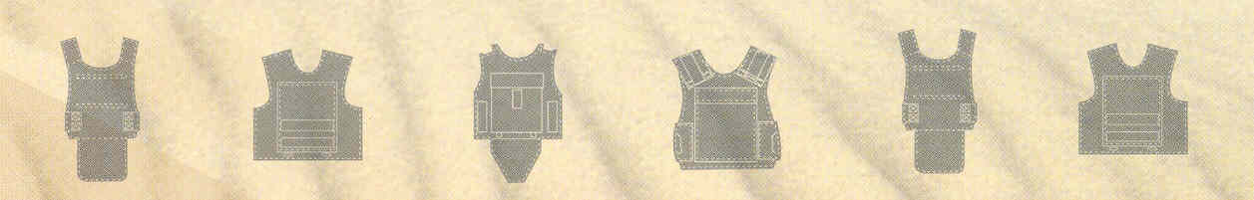

The panel can be produced in a wide variety of sizes and shapes, or as a raw ballistic panel.

Performance
Ballistic performance:
KNIGHTEX™ ballistic panel is designed to stop the following types of ammunition according to NIJ 0104.01:
NIJ level | Bullet | Bullet weight (grains) | Max. velocity ft/sec (m/sec) | No. of strikes
IIIA | 9 mm FMJ | 124 | 1430 (436)±30 (9.2) | 6
IIIA | .44 Mag. SWC | 240 | 1430 (436)±30 (9.2) | 6

Fragmentation performance:
KNIGHTEX™ ballistic panel is designed to offer protection in accordance with MIL-STD 662 Standard, as follows:
Fragment FSP weight  (Grains) | V₅₀  Ft/sec (m/sec)
17 | 1640 (500)

Physical data
Weight & sizes
Size | Weight
1 Square meter | 4.2 Kg.
1 Square feet | 0.88 Lb.

Color:
Standard colors are black, olive green and navy blue.
The panel can be painted in any Pantone or RAL color, according to the client’s specific requirements. However, for small quantities, a special charge may apply for some color tones.

Materials:
Item | Material
Panel body | Composite Aramid
Cover | Nylon

Accessories and Advanced Capabilities
KNIGHTEX™ ballistic panel can be supplied with a wide range of optional accessories:
- Camouflage cover
- Stub resistance /Fragmentation/Anti-Riot capabilities
- Ultra flexible
- Bag

Warranty
Rabintex offers ten (10) years of warranty for the ballistic performance of the panel.
The cover and non-ballistic components are warranted for two (2) years.

Quality Assurance
Rabintex fully complies with ISO 9001 and 9002 Quality Standard.

